BATTERIES & WIRING

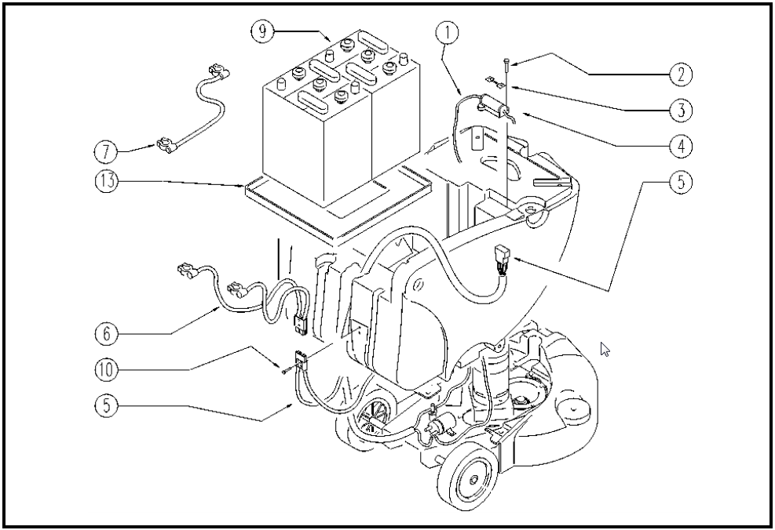
 | ITEM | SKU | Description | QTY | FROM
 | 1 | MECB00728 | WIRING FUSIBILE | 1 | 10/2002
 | 2 | E88004 | Screw, Machine M4 x 12 Watchman 20/24 | 2 | 10/2002
 | 3 | E87883 | 60 AMP Fuse for WS20/24 | 1 | 10/2002
 | 4 | E86373 | master fuse carrier WS20/24 | 1 | 10/2002
 | 5 | E86370 | wiring harness WS24 | 1 | 10/2002
 | 6 | E87846 | Battery Cable Harness w/50A Red Connector | 1 | 10/2002
 | 7 | E86433 | Cable, 6 AWG, Black, 17" L, 1R & 1L Bat Term | 1 | 10/2002
 | 9 | E11767 | BATTERY | 2
 | 10 | E86597 | SCREW | 2 | 10/2002
 | 13 | PMVR00881 | PLATE | 1 | 10/2002

